4 System Interface Designs:

There are two parts to planning the framework interface. One is to plan client interfacing, and the moment is to plan to interface that interface with other frameworks, which are both basic to the system's working.

4.4 System Navigation Diagram:

Front End:

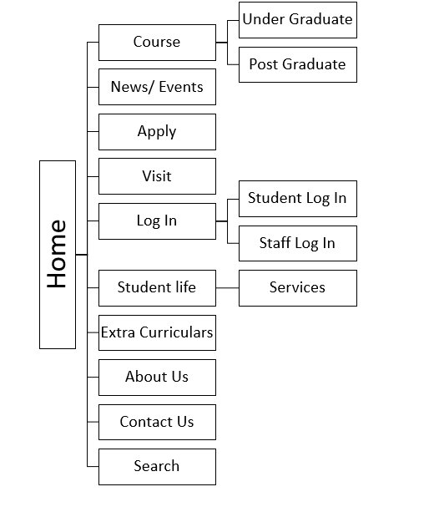

System Login:

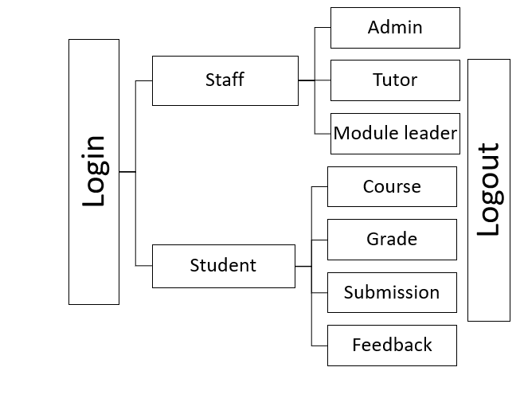

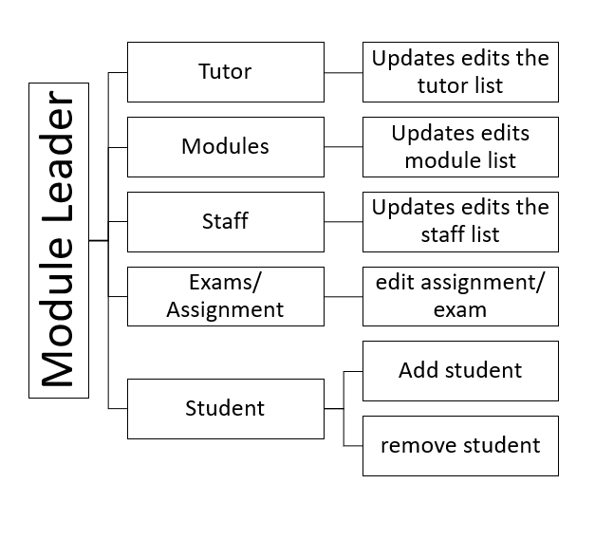

WireFrame of RMS:

A wireframe is a visual representation of a website's functionality. A wireframe is a process of sketching project sites and functionality on a page while taking user wants and excursions into consideration. Wireframes are used early in the development process to define the basic structure of a website before adding visual content and design.

A wireframe is a visual representation of how interface elements will appear on key pages on the web. It's an important part of the interaction design process.

The goal of a wireframe is to offer a visual representation of a page early in the project so that stakeholders and project team members may approve it before the creative phase begins. Prototyping can also benefit from wireframes.

4.7.1 Wireframes

Home page RMS wireframe:

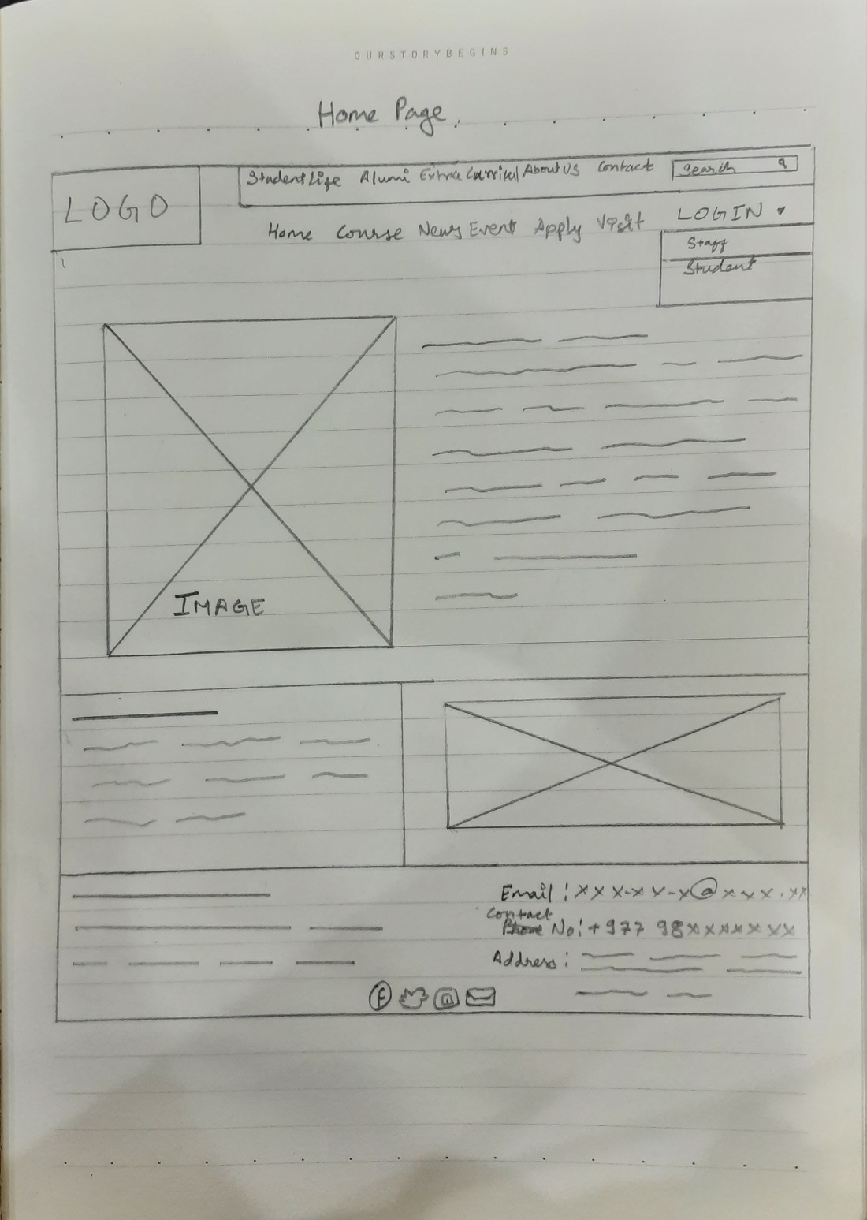

1. This is where the university logo kept.
2. This is the Naviagtion Menu
3. Search bar for searching system navigation.
4. Pannels for images.
5. Place for text (Introduction)
6. This is the Footer with contact info.

Course page RMS wireframe:

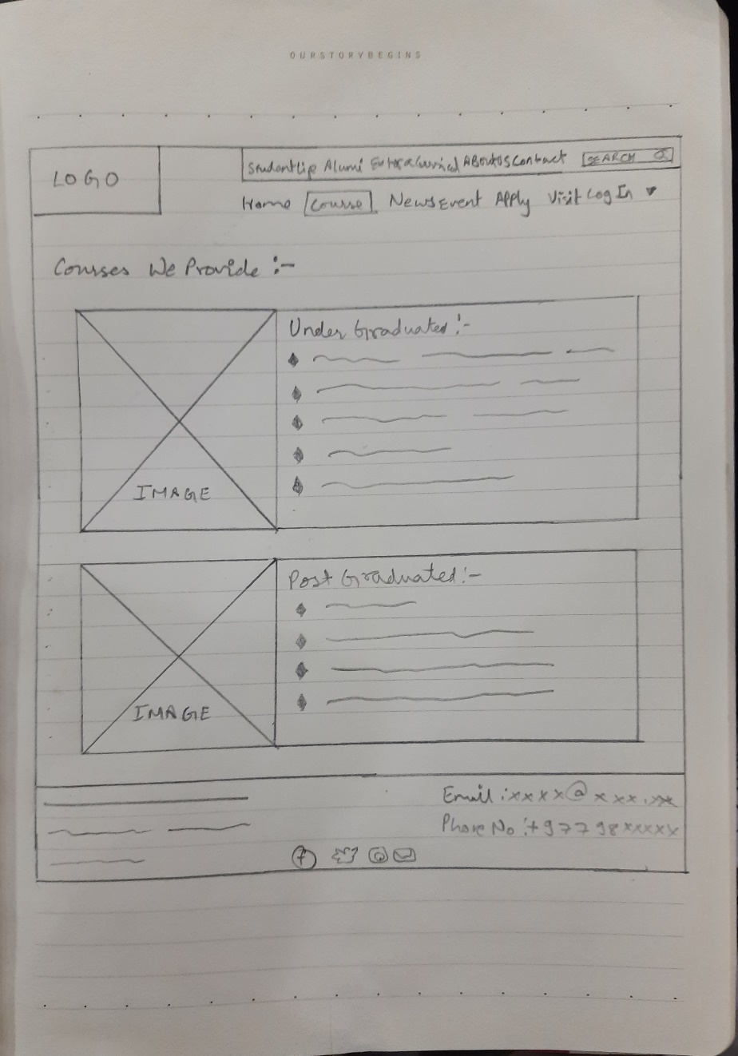

1. This is where the university logo kept.
2. This is the Naviagtion Menu
3. Search bar for searching system navigation.
4. This is the courses table.
5. Information about courses provided to Under Graduate .
6. Information about courses provided to Post Graduate .
7. This is the Footer with contact info.

News/ Event page RMS wireframe:

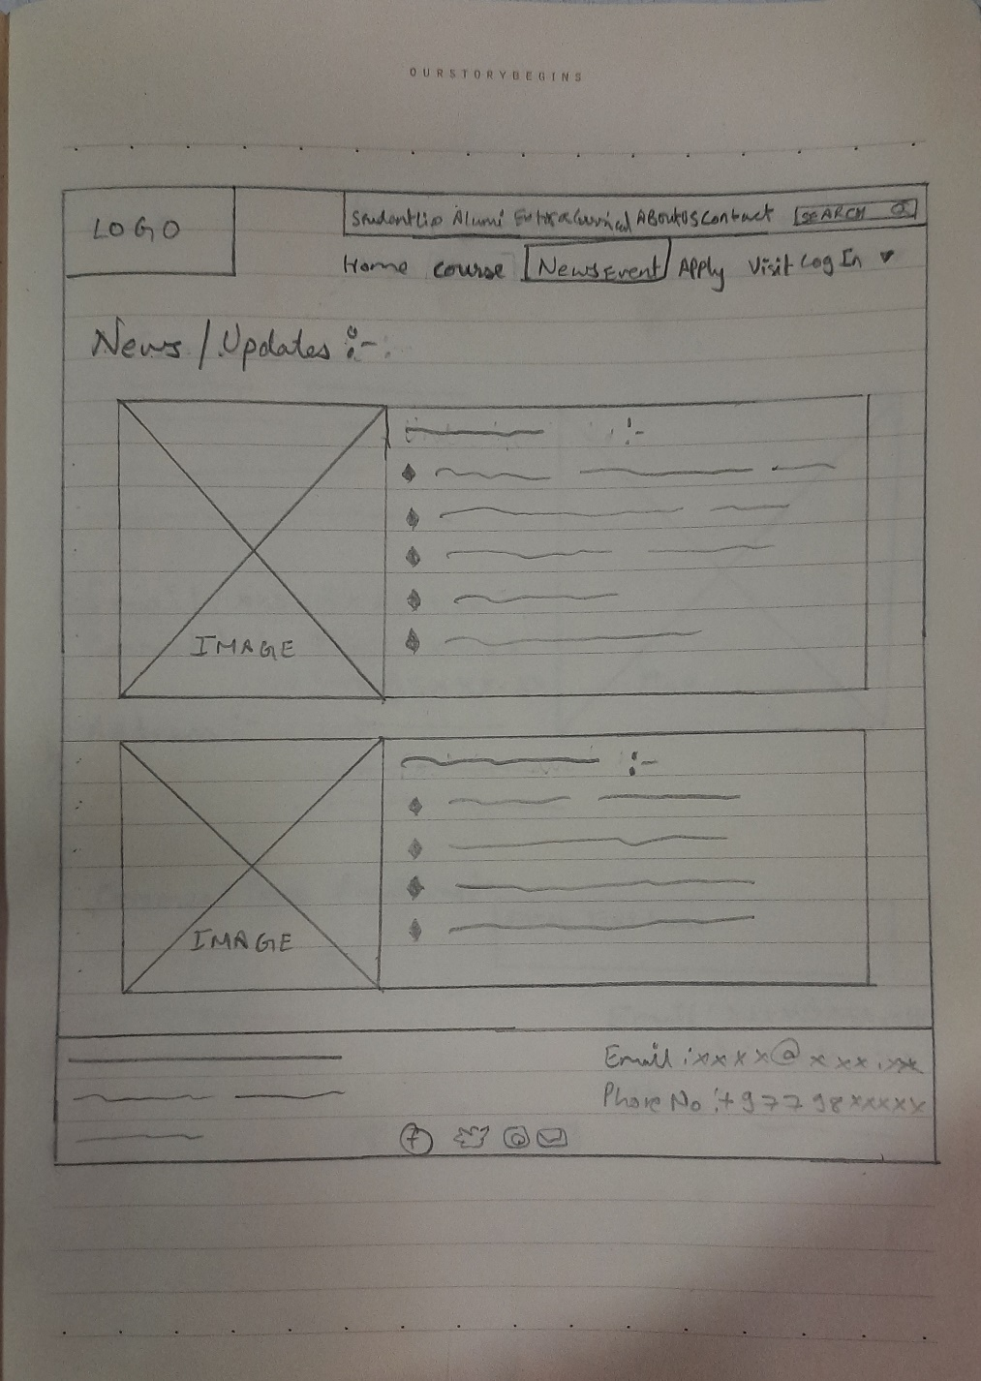

1. This is where the university logo kept.
2. This is the Naviagtion Menu
3. Search bar for searching system navigation.
4. This is the news/ event table.
5. Latest News will be shown here .
6. Latest event will be shown here.
7. This is the Footer with contact info.

Apply page RMS Wireframe:

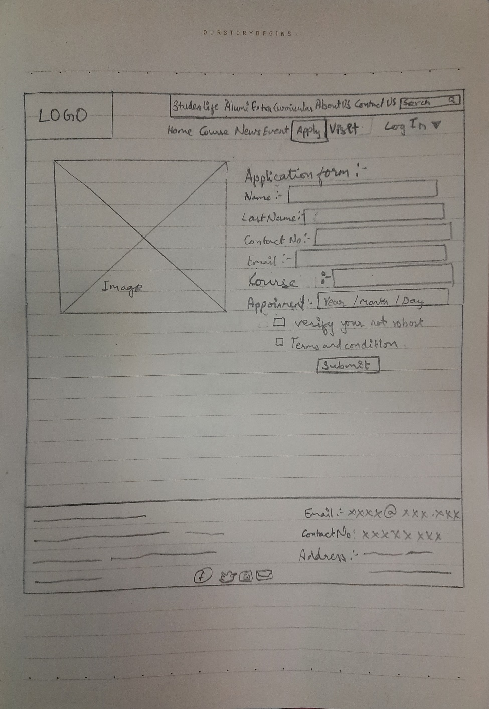

1. This is where the university logo kept.
2. This is the Naviagtion Menu
3. Search bar for searching system navigation.
4. Form to apply for admission.
5. Appoinment Date selection.
6. Human verification .
7. Terms and condition.
8. This is the Footer with contact info.

Visit RMS Wireframe:

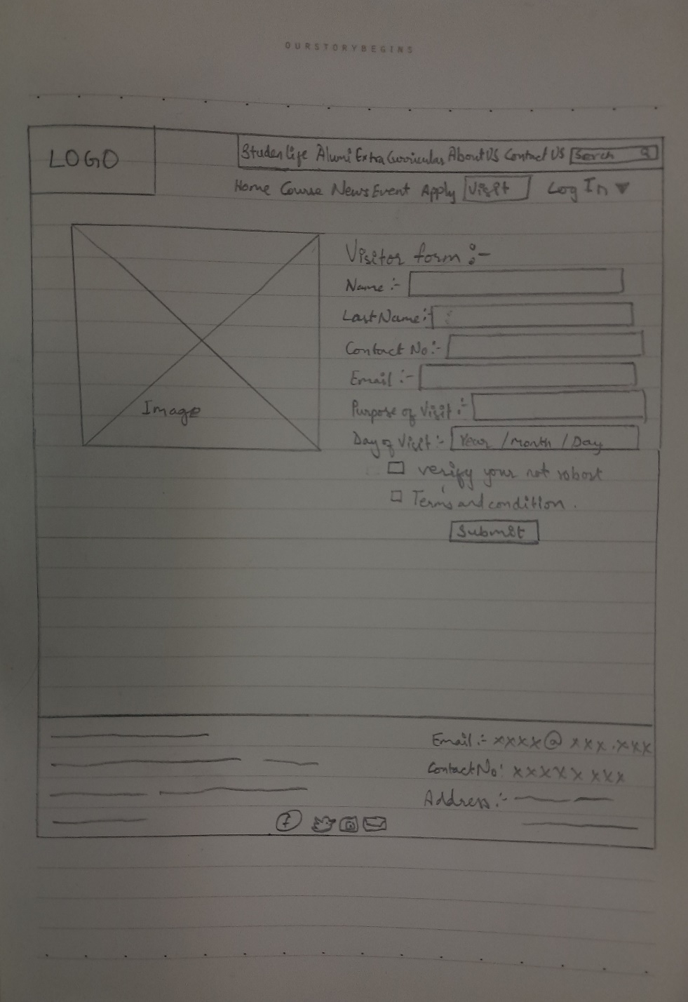

1. This is where the university logo kept.
2. This is the Naviagtion Menu
3. Search bar for searching system navigation.
4. Form for university visit.
5. Appoinment Date selection.
6. Human verification .
7. Terms and condition.
8. This is the Footer with contact info.

Contact page RMS Wireframe:

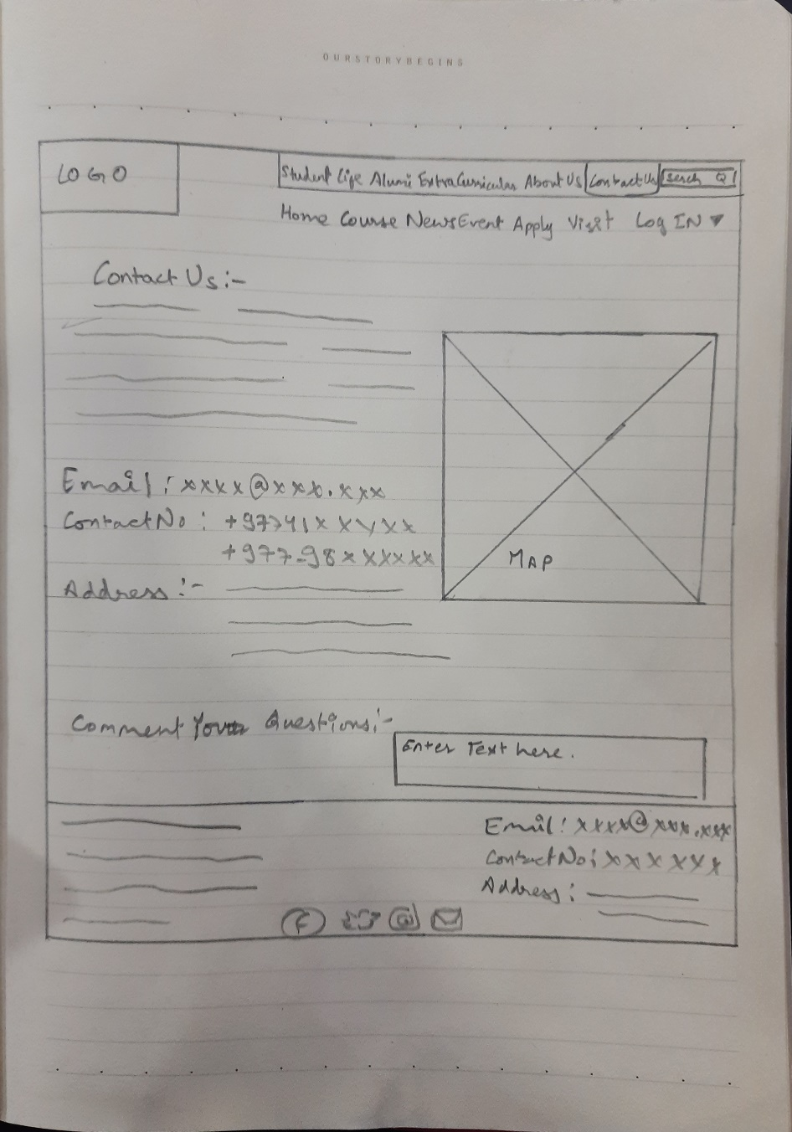

1. This is where the university logo kept.
2. This is the Naviagtion Menu
3. Search bar for searching animals RMS.
4. This is the page contains contact details for university.
5. Map with location of university.
6. This is palce is for map.
7. Place to leve comment/ feedback.
8. This is the Footer with contact info.

4.4.1Student logIn page RMS Wireframe:

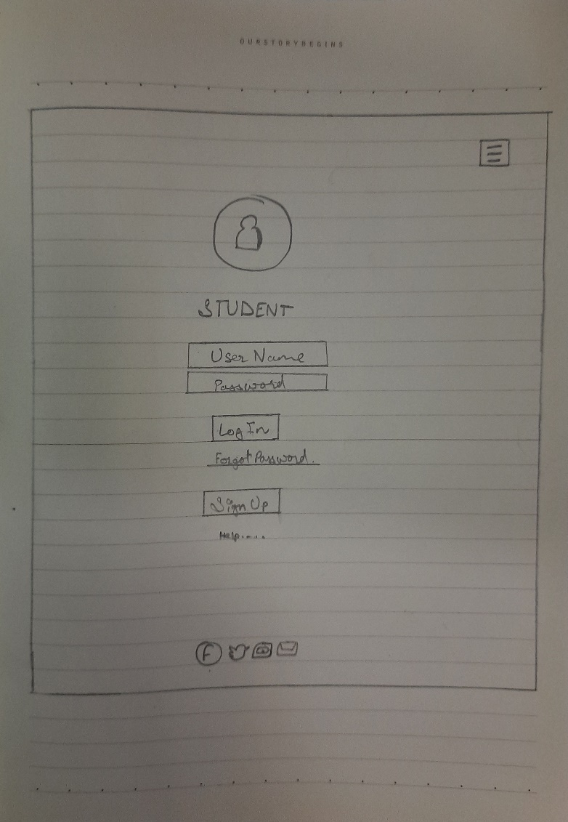

1. This is where the university logo kept.
2. This is the Hamburgure Naviagtion Menu
3. Place to enter User name .
4. Place to enter password .
5. Forgot password.
6. Sign up for new students.
7. This is the Footer with contact info.

Staff logIn page RMS Wireframe:

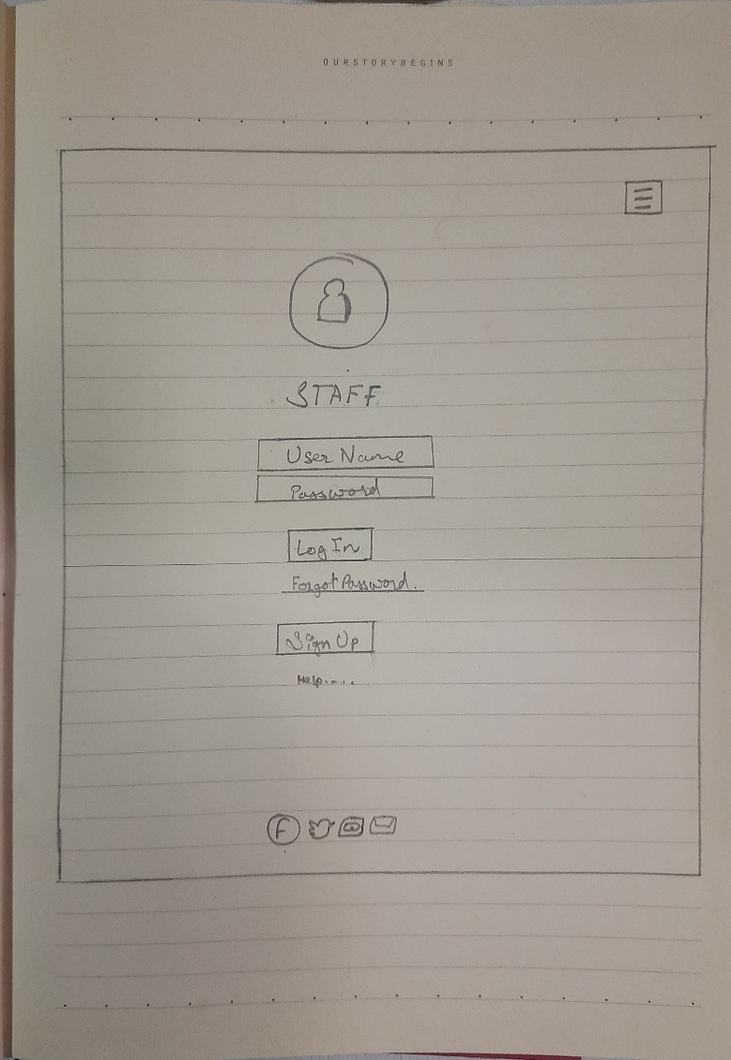

1. This is where the university logo kept.
2. This is the Hamburgure Naviagtion Menu
3. Place to enter User name .
4. Place to enter password .
5. Forgot password.
6. Sign up for new staff.
7. This is the Footer with contact info.

Student portal home page RMS Wireframe:

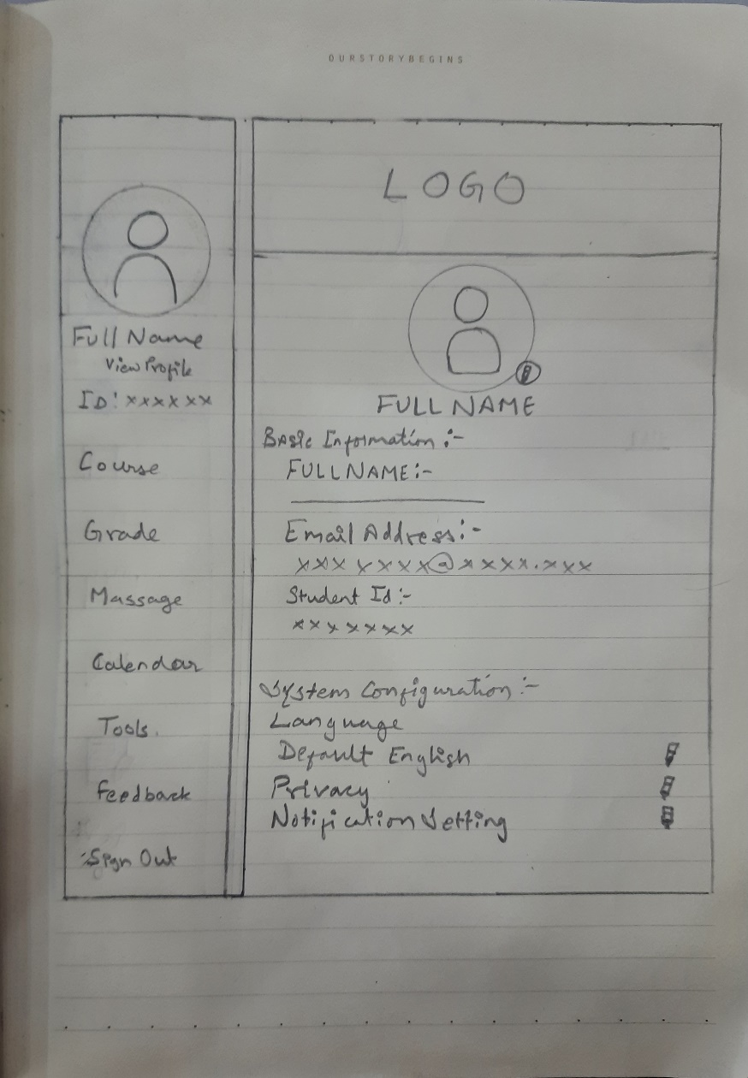

1. This is where the university logo kept.
2. Profile picture.
3. Side menu bar.
4. Chanagable profile picture .
5. Basic information.
6. System configuration.

Student portal course page RMS Wireframe:

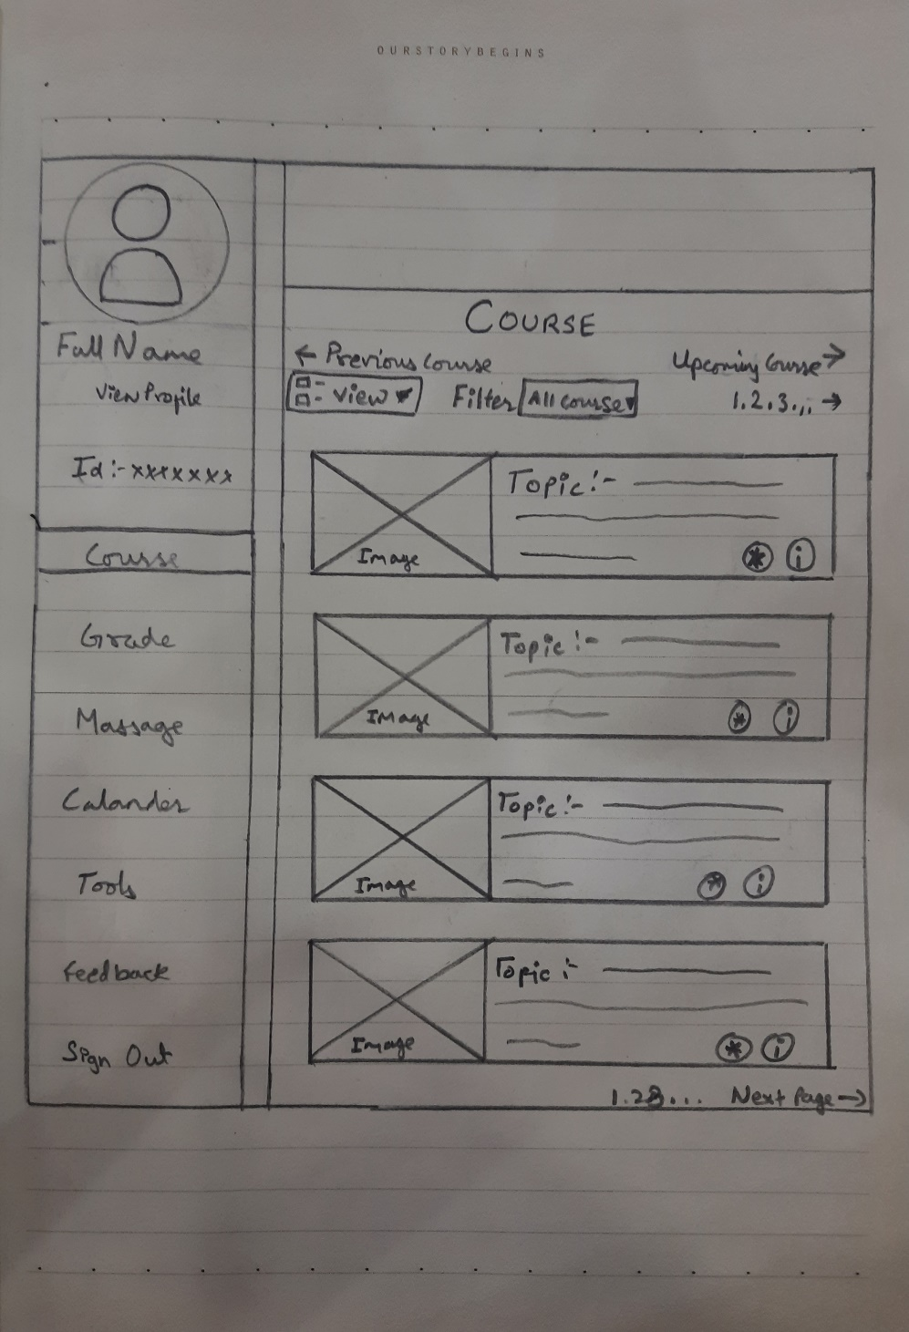

1. Course title is kept.
2. Profile picture.
3. Side menu bar.
4. Course list .
5. Previous and next course list.
6. Filter.
7. Page index.

Student portal grade page RMS Wireframe:

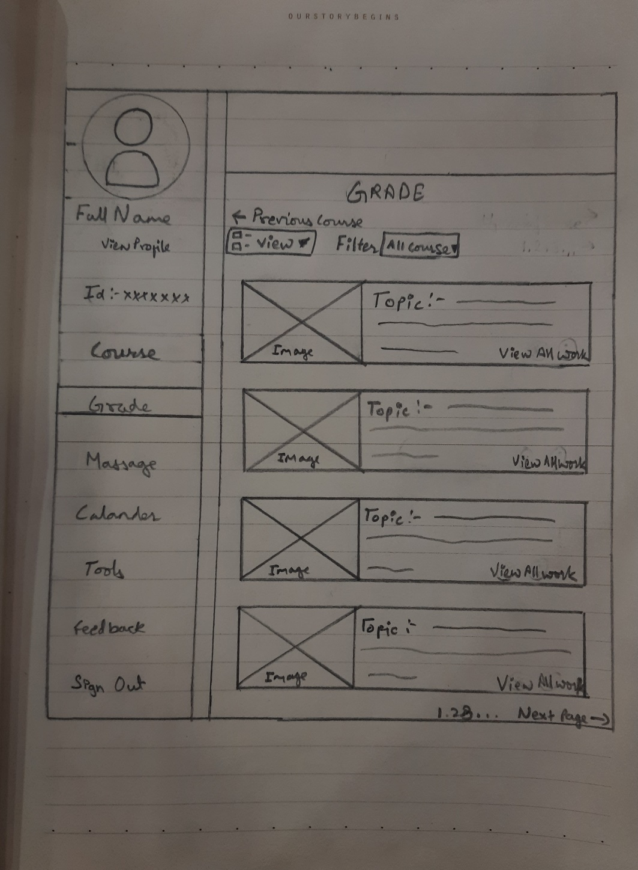

1. Grade title is kept.
2. Profile picture.
3. Side menu bar.
4. Course list .
5. Previous and next course list.
6. Filter.
7. Grade list.
8. Page index

Student portal message page RMS Wireframe:

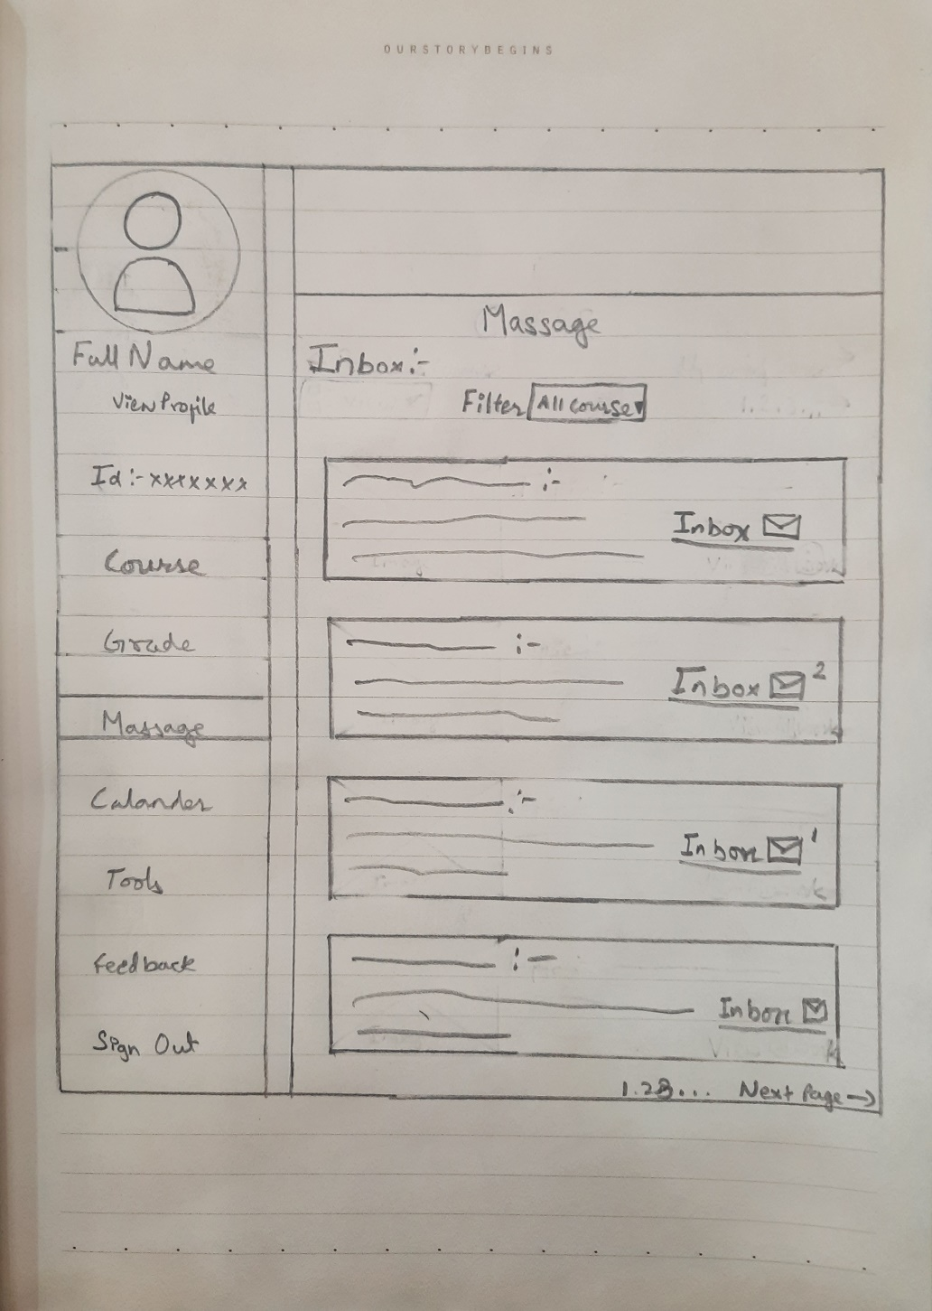

1. Message title is kept.
2. Profile picture.
3. Side menu bar.
4. Inbox .
5. Previous and next message list.
6. Filter.
7. Page index

Student portal calander page RMS Wireframe:

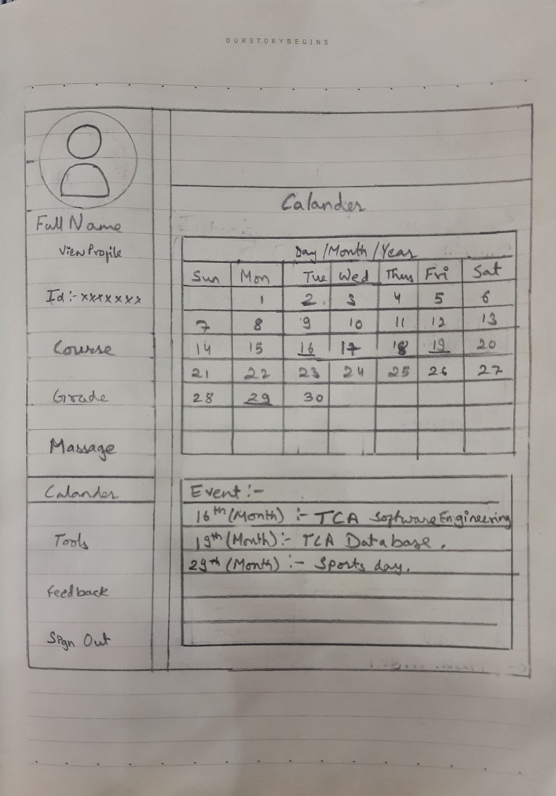

1. Calander title is kept.
2. Profile picture.
3. Side menu bar.
4. Calander .
5. Previous and next month.
6. Filter.
7. Event list.

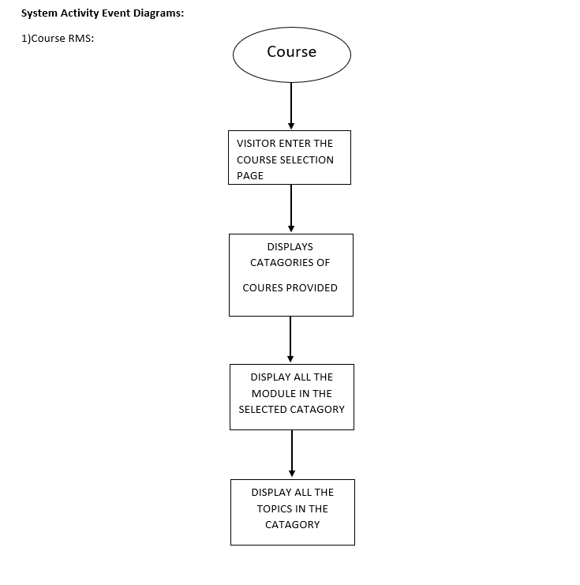

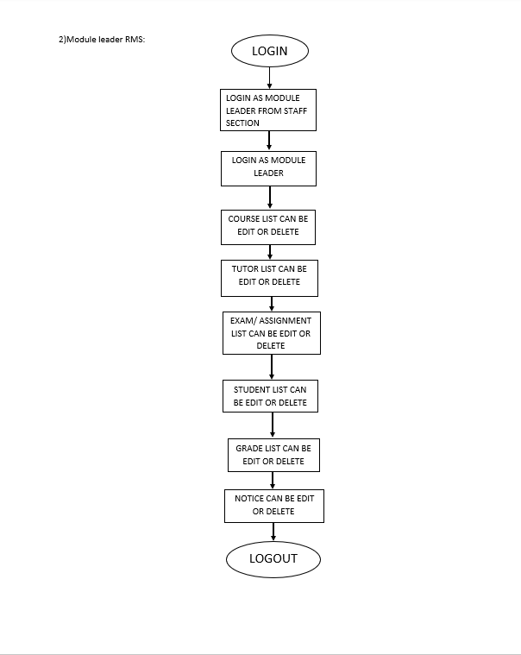

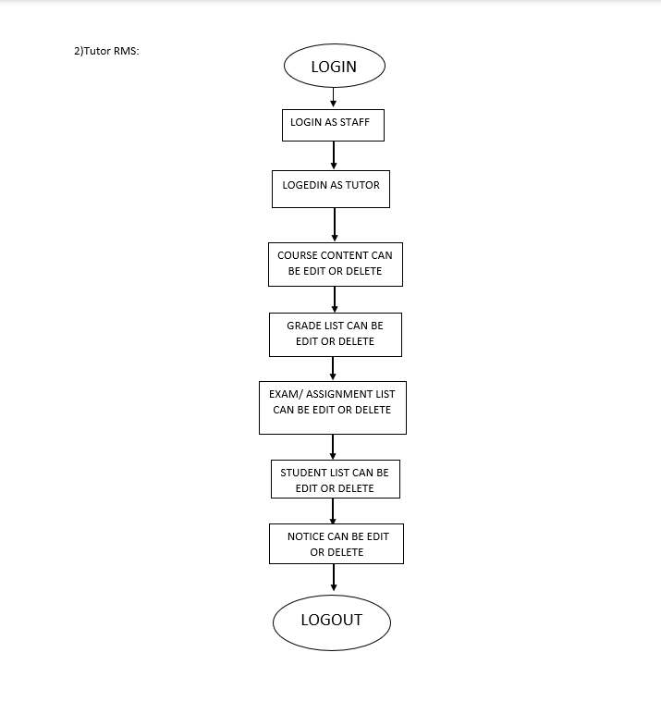



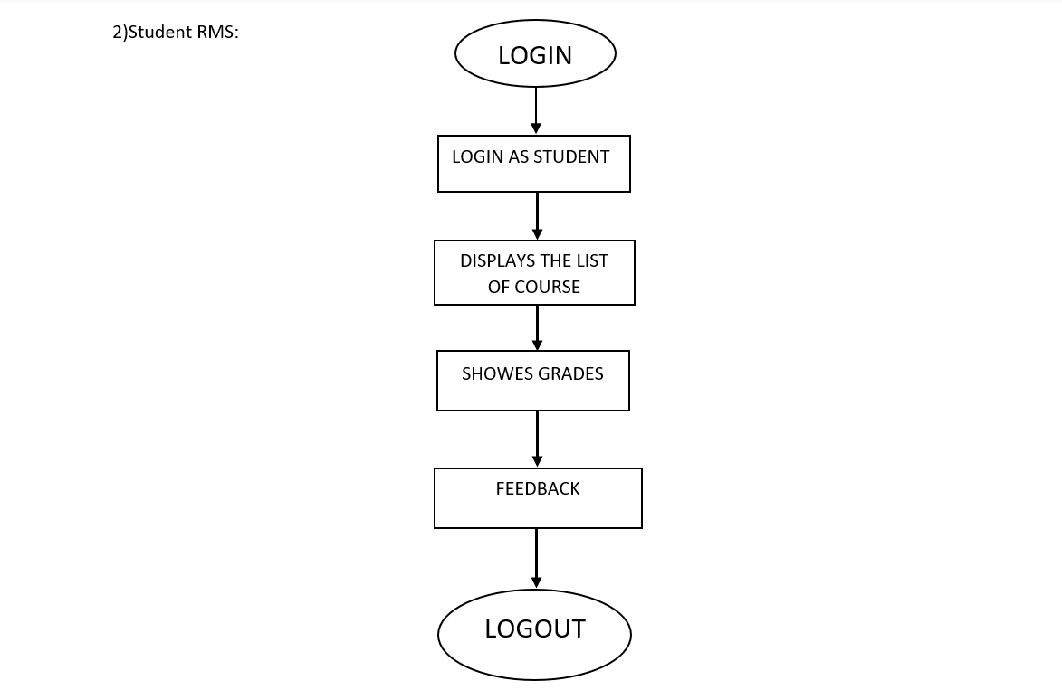

4.7.3 System Screen Mockup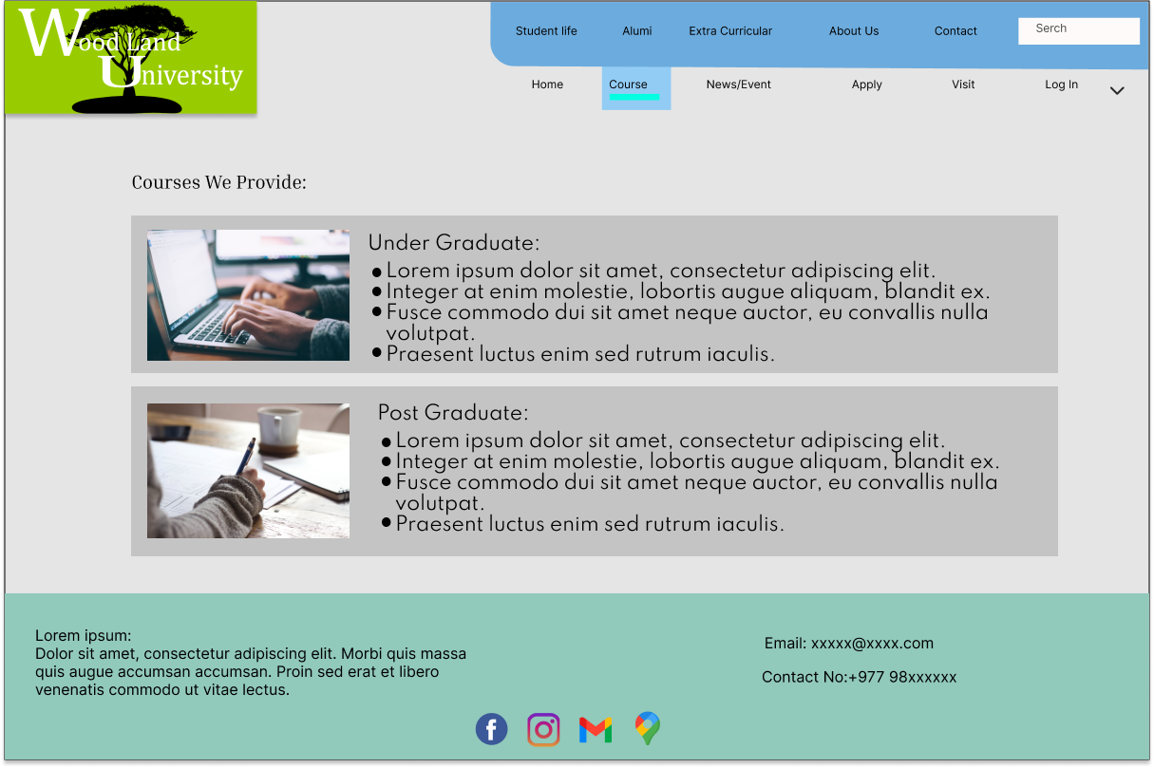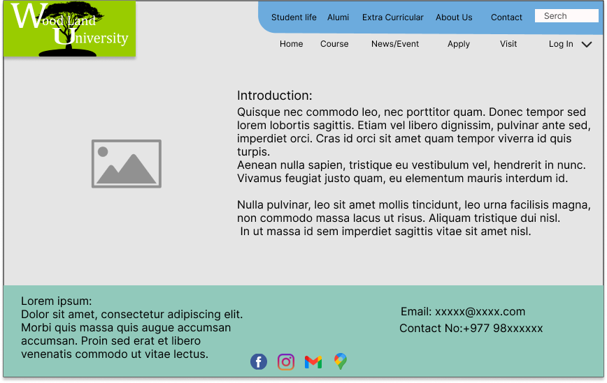

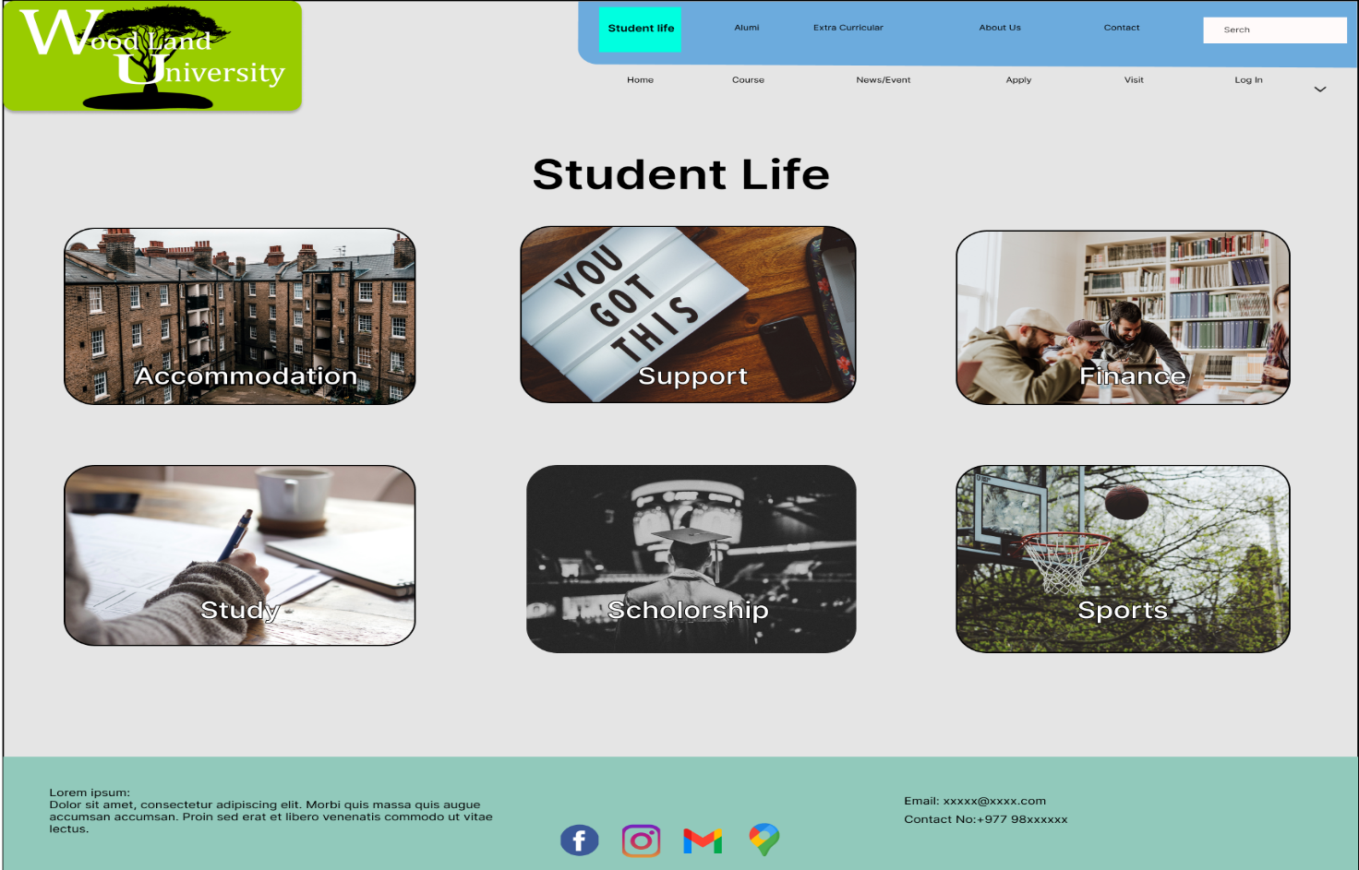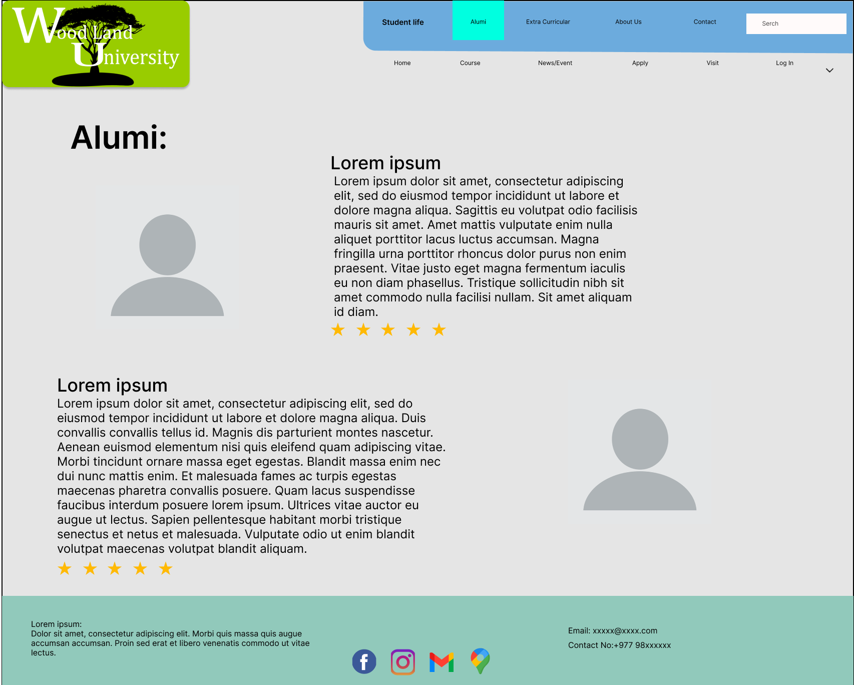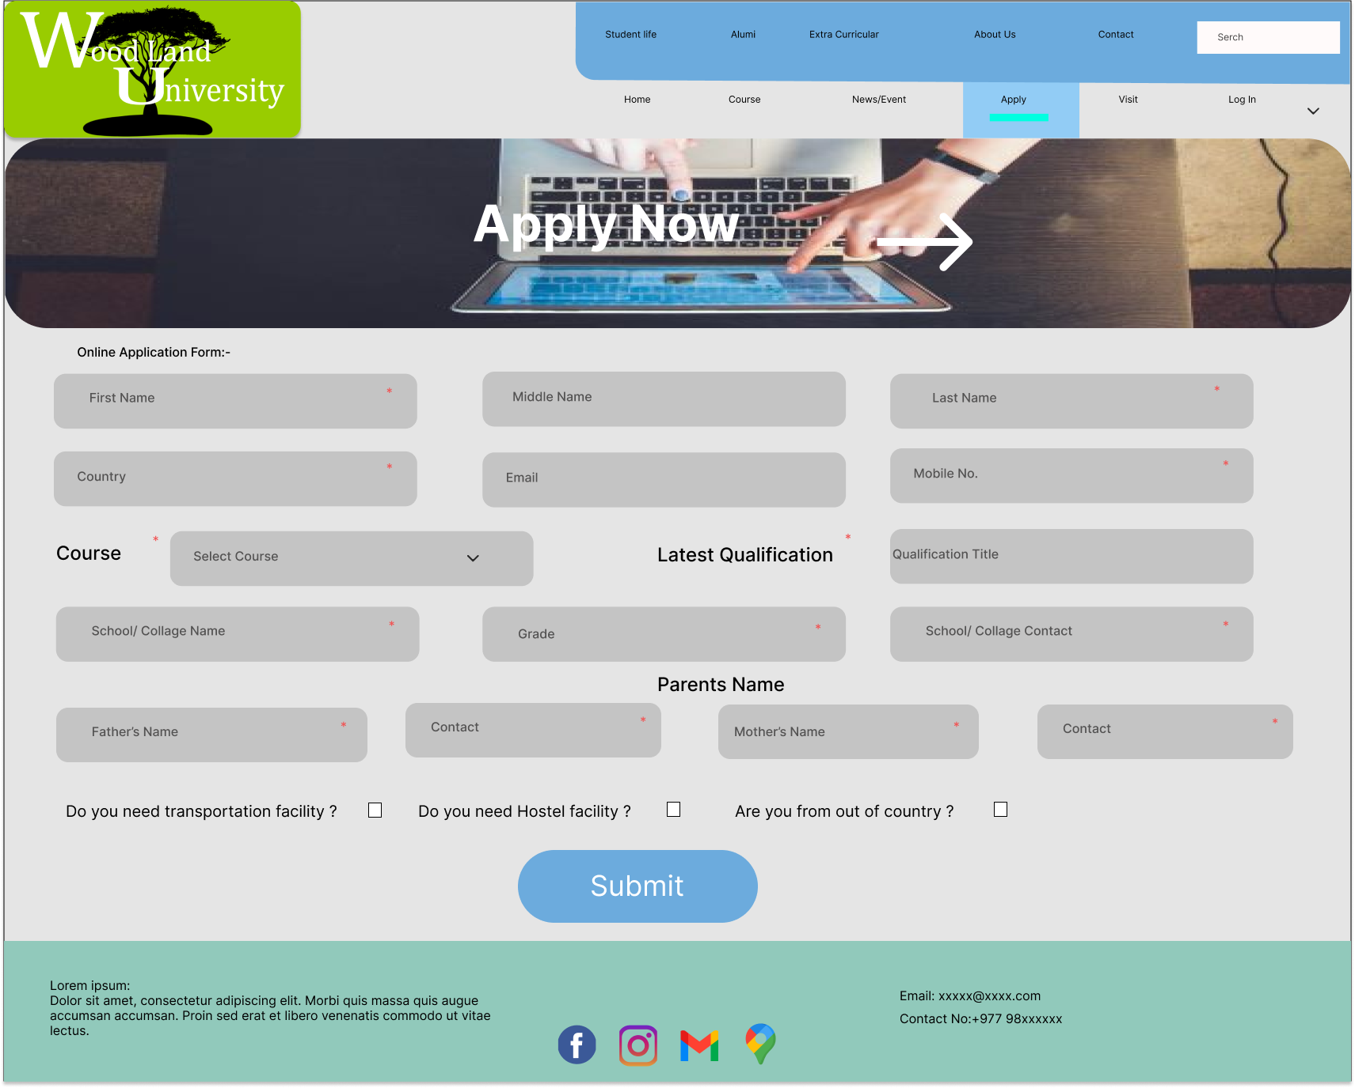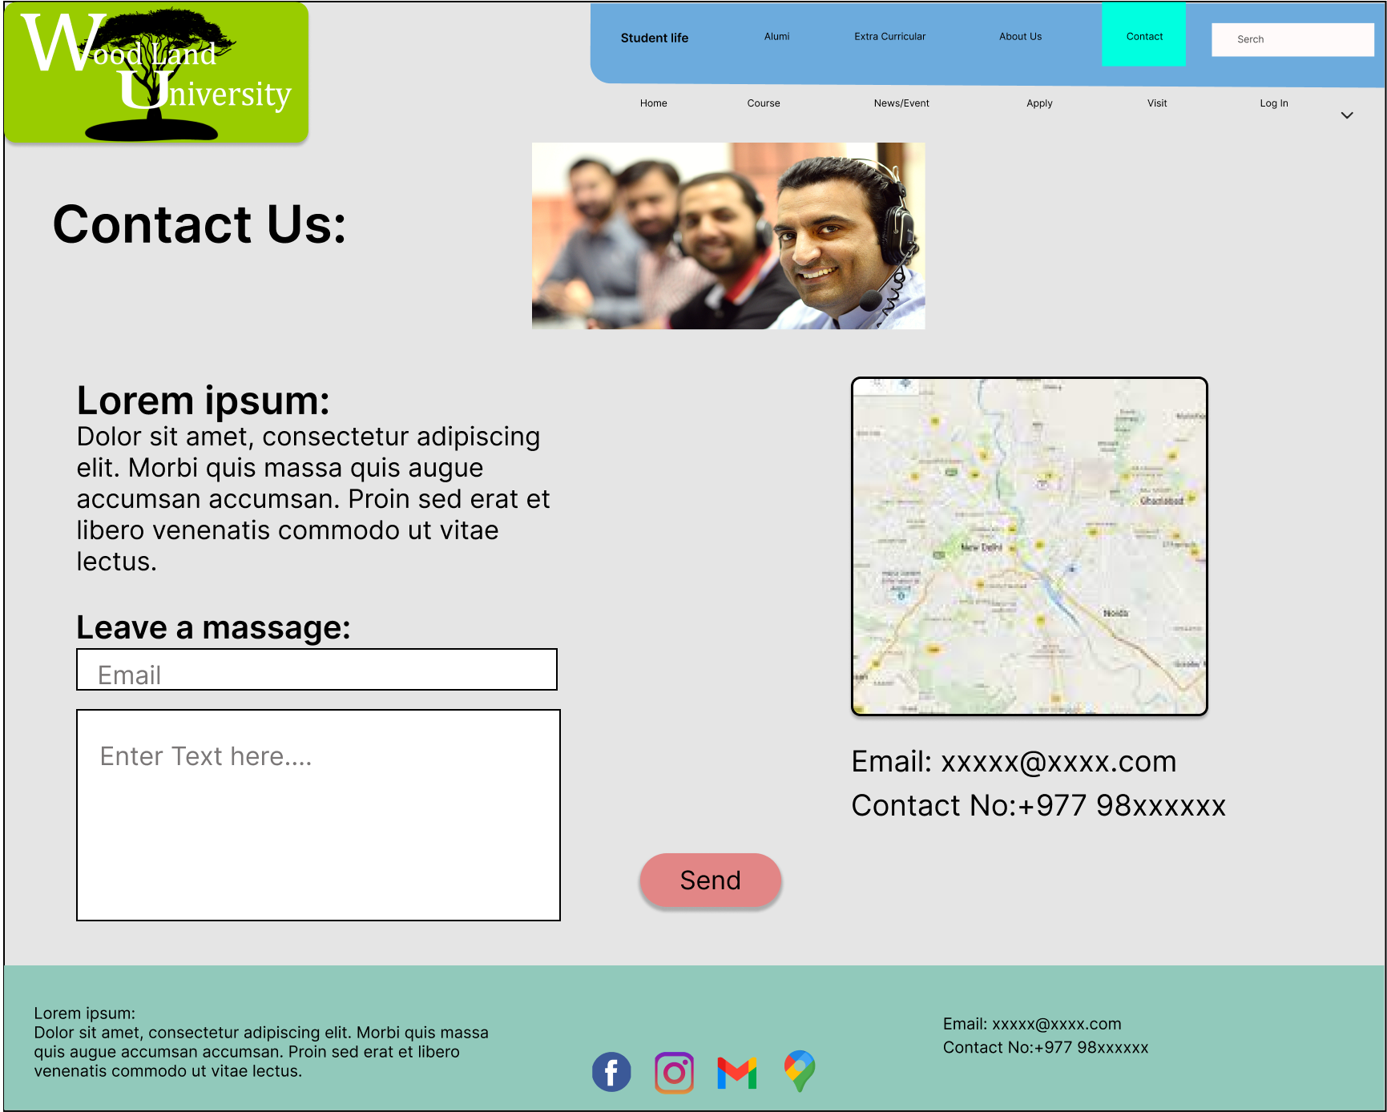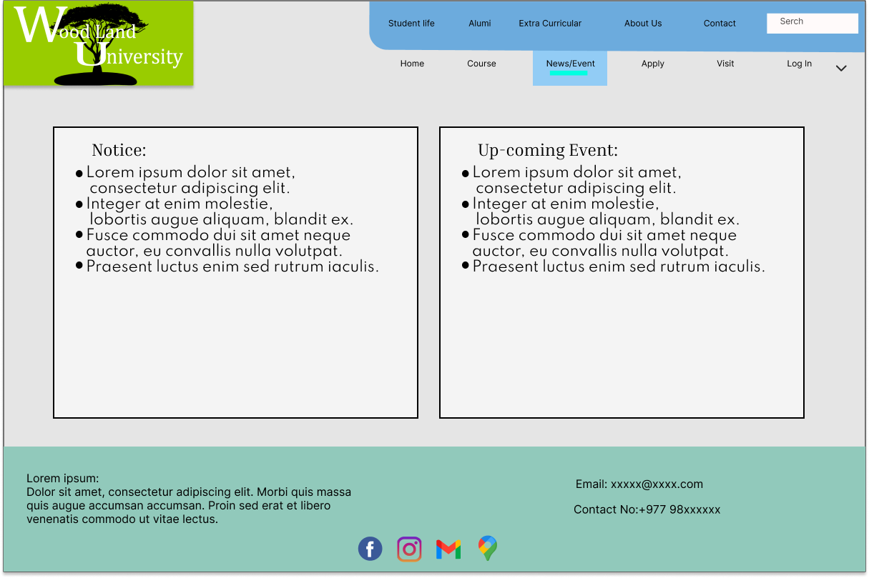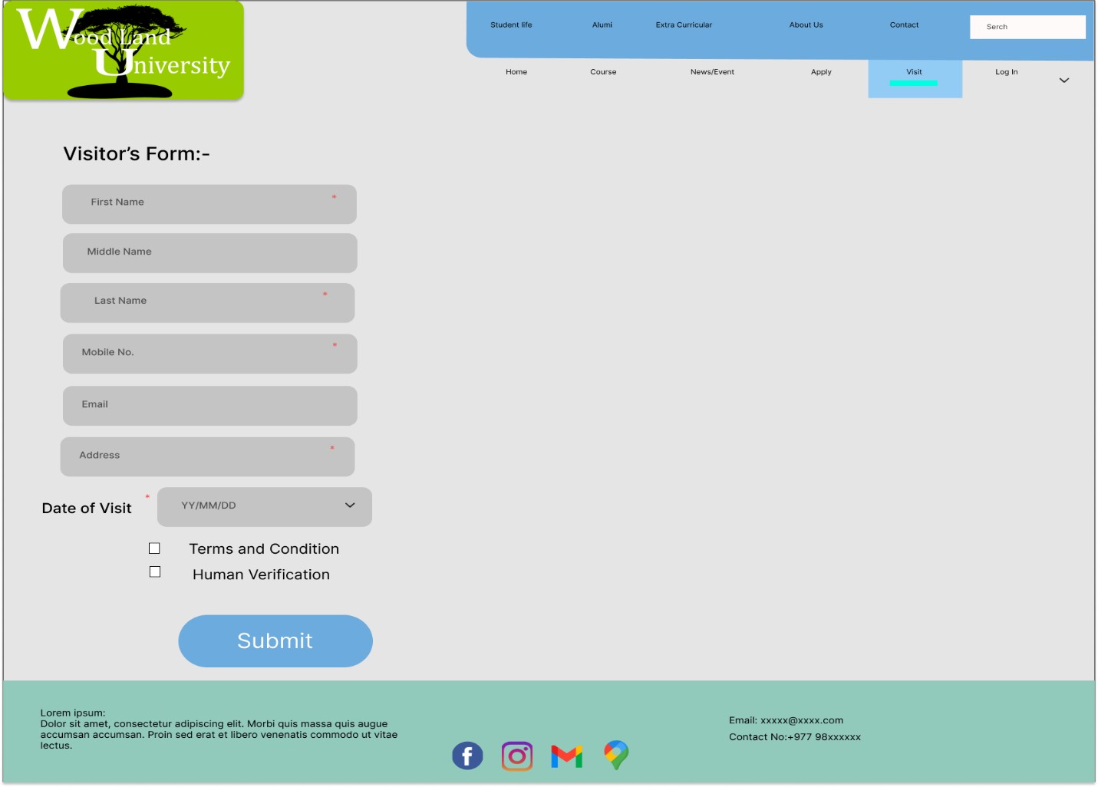

4.4.3 System screen mockup

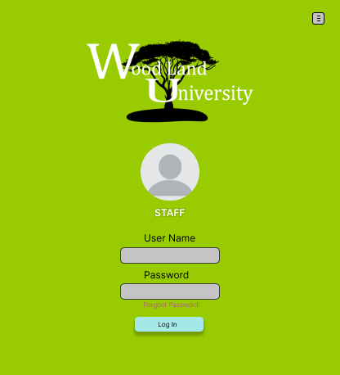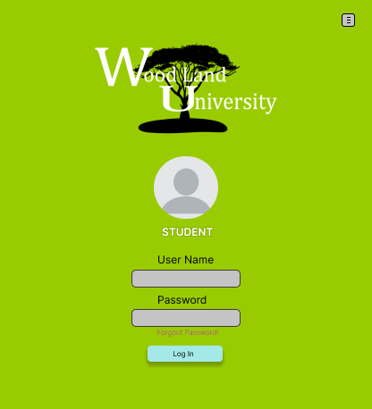

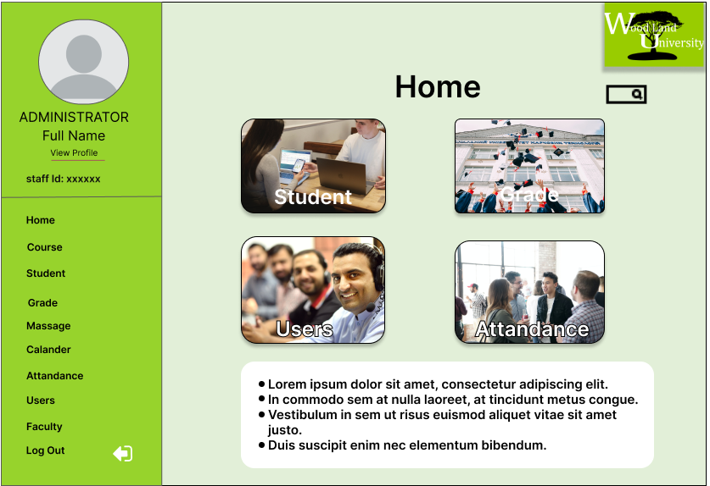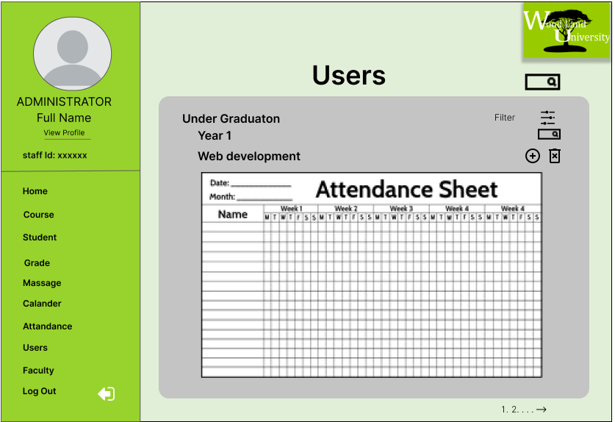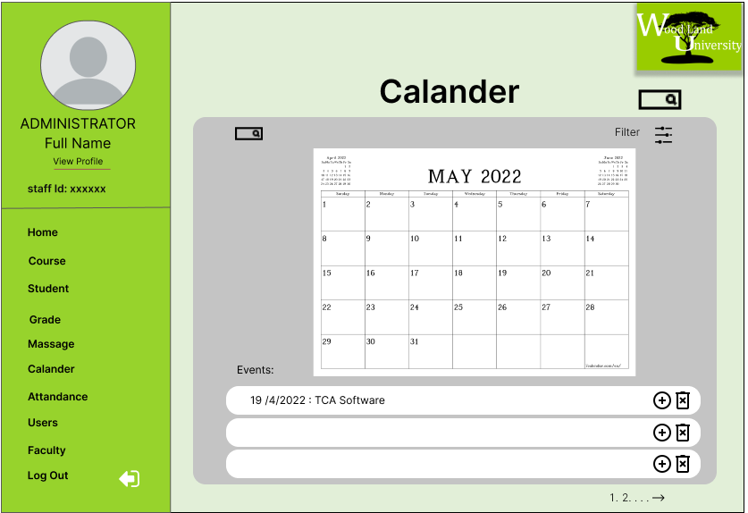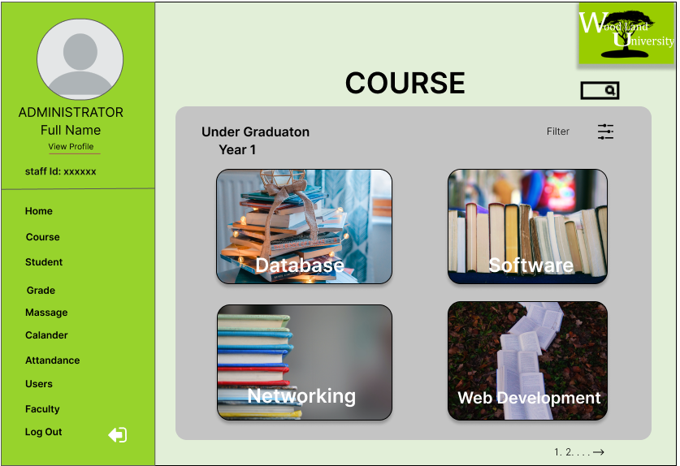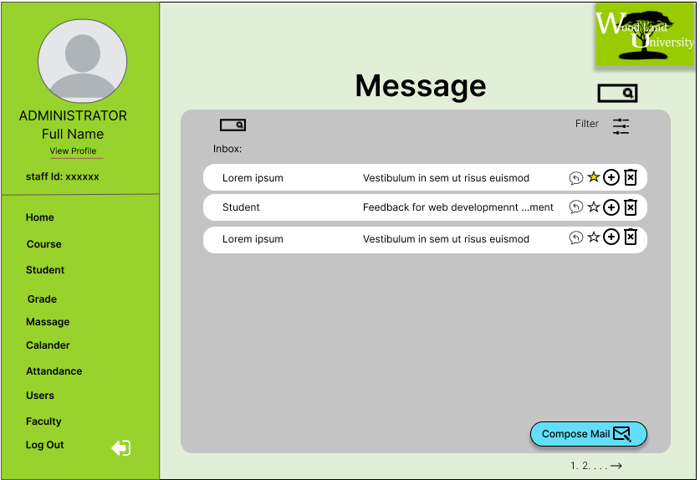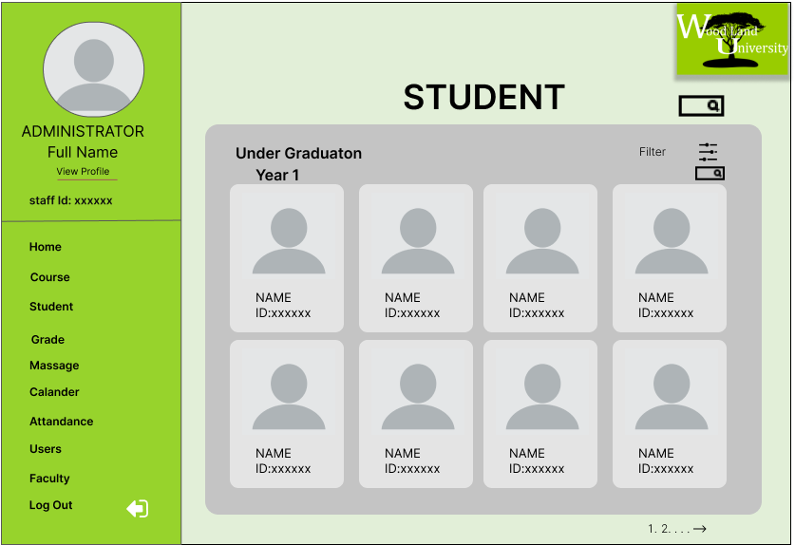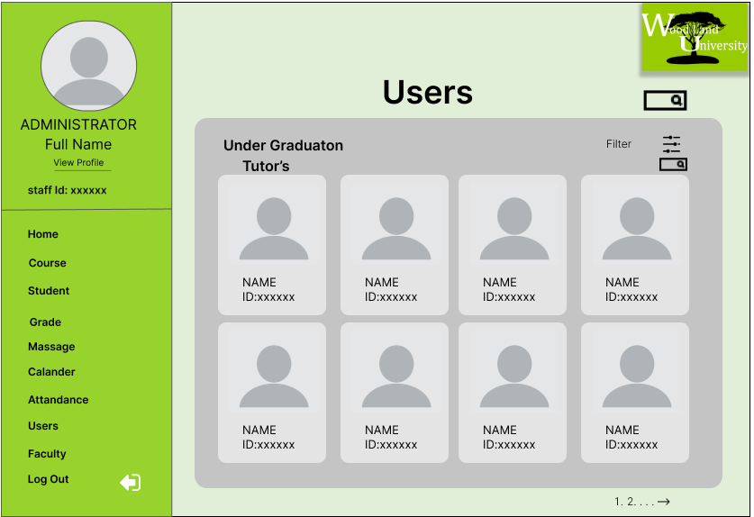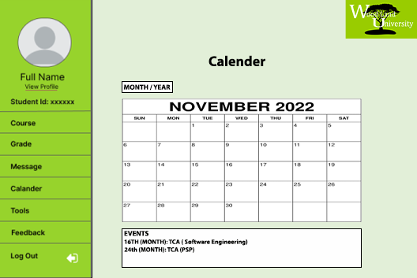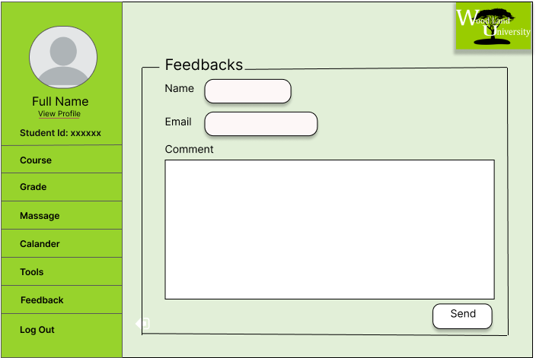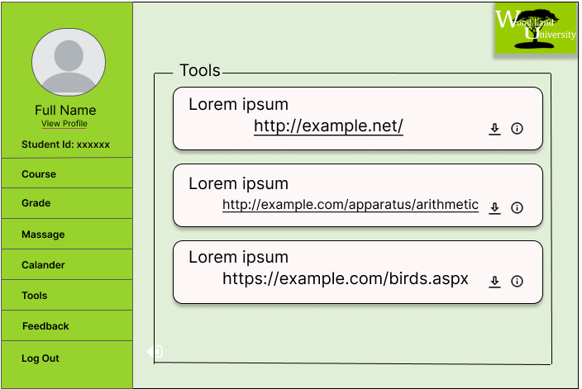

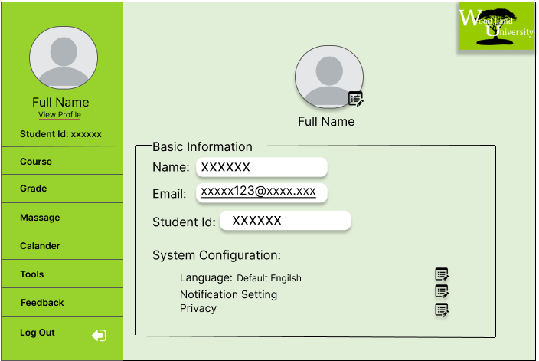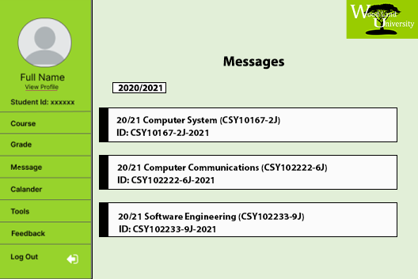

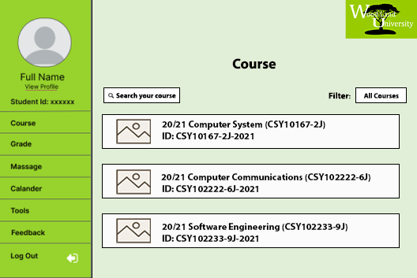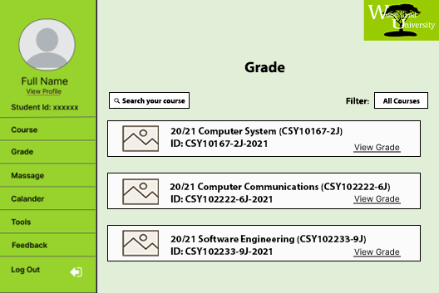

4.45 / 4.8Design Revision:

While designing the system, we sought to keep it as simple and user-friendly as possible. We attempted to keep our system as simple as possible. The system was created to meet the needs of the users. In response to client requests, we've added a few extra features.

We wanted to set ourselves out from the competition. We wanted to add some unique features to our system, as requested by our clients. Add a tool that allows the module leader to deliver a message to all students and tutors.

**4.6Heuristic Evaluation Analysis**

The following usability criteria have been assessed in an attempt to evaluate the suitability of provisional system designs against established good design principles.

Conformity Key

1 = Conforms in all parts.

2 = Conforms in most parts.

3 = Conforms in some parts.

4 = Does not conform.

|  |  |  |  |
| --- | --- | --- | --- |
| **Usability Criteria (Heuristics)**  **Appropriate use of:** | **Level of Conformity**  **(1-4)** | **Evidence/Examples of application** | **Additional Comments/Issued Raised** |
| **Metaphors** |  |  |  |
| **Consistency/**  **Perceived Stability** |  |  |  |
| **WYSIWYG** |  |  |  |
| **User Centered**  **Control** |  |  |  |
| **Feedback and Dialog** |  |  |  |
| **Forgiveness** |  |  |  |
| **Interface Text** |  |  |  |
| **Buttons** |  |  |  |
| **Icons** |  |  |  |
| **Color** |  |  |  |
| **Mode lessness** |  |  |  |

**4.9Heuristic Evaluation Analysis**

The following usability criteria have been assessed in an attempt to evaluate the suitability of provisional system designs against established good design principles.

Conformity Key

1 = Conforms in all parts.

2 = Conforms in most parts.

3 = Conforms in some parts.

4 = Does not conform.

|  |  |  |  |
| --- | --- | --- | --- |
| **Usability Criteria (Heuristics)**  **Appropriate use of:** | **Level of Conformity**  **(1-4)** | **Evidence/Examples of application** | **Additional Comments/Issued Raised** |
| **Metaphors** |  |  |  |
| **Consistency/**  **Perceived Stability** |  |  |  |
| **WYSIWYG** |  |  |  |
| **User Centered**  **Control** |  |  |  |
| **Feedback and Dialog** |  |  |  |
| **Forgiveness** |  |  |  |
| **Interface Text** |  |  |  |
| **Buttons** |  |  |  |
| **Icons** |  |  |  |
| **Color** |  |  |  |
| **Mode lessness** |  |  |  |